How to Claim CE Credit for Regularly Scheduled Series in CE Central
Navigate to https://ww2.highmarksce.com/ummc/ and select ‘Login.’ Sign in with your CE Central credentials (Please note: these are not your UMMC credentials if you are a UMMC employee, and will not update as your UMMC credential )
If you don’t already have an account you can click ‘Login’ and you will be prompted to create an account. (*See tutorial on how to create a CE Central account.)
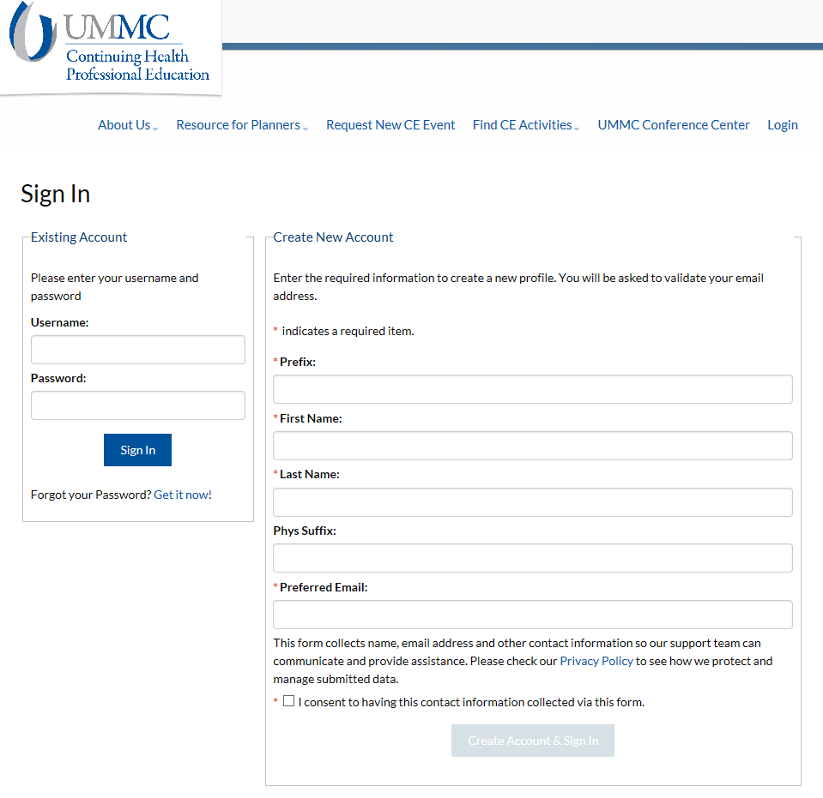
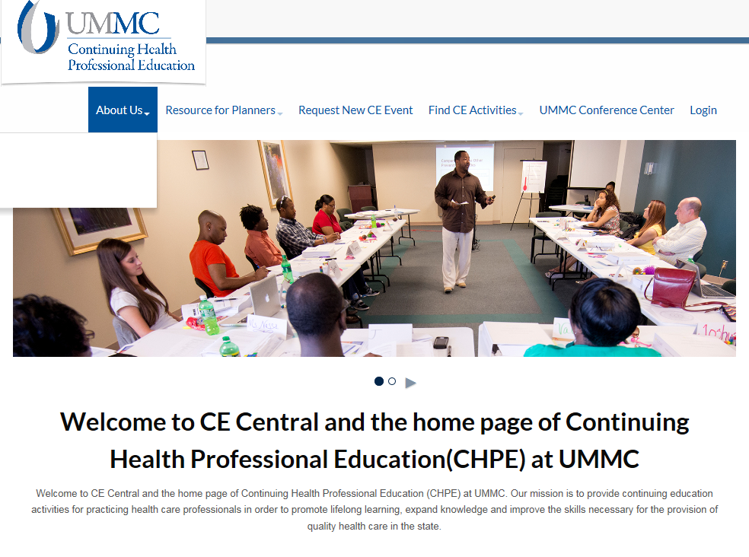
- From the Dashboard, go to ‘Claim by Authorization Code’ under the ‘My Credits’ tab.
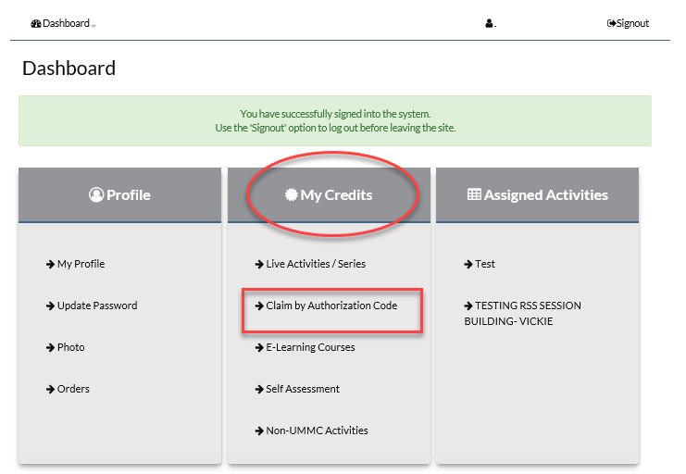
- Enter the ‘Authorization Code’ provided to you from the session you attended, then ‘Submit.’
PLEASE NOTE: You have up to 30 days from the date of the event to claim credit with this code, and it IS case sensitive.
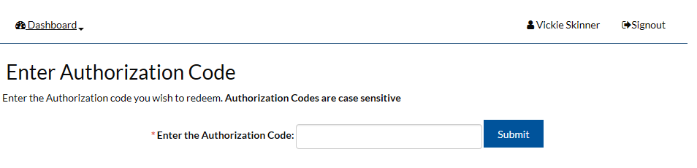

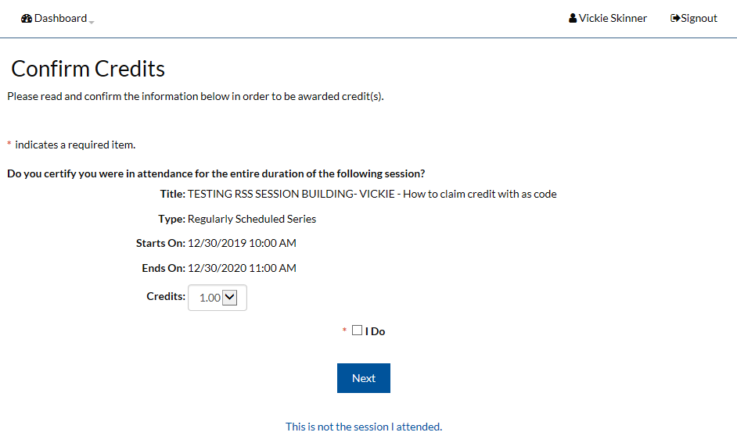
- Next, you will be prompted to certify that you attended the session and adjust credits if needed, then click ‘Next.’

Example: If you only attended
half the session you can adjust
to claim credit only for the portion
you attended.

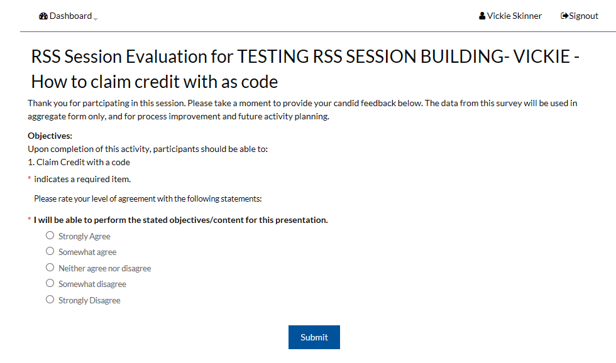
- Complete the ‘Session Evaluation,’ and click ‘Submit.’
- You now have the option to print your certificate, email your certificate, edit the session evaluation if needed, or remove the credit if it was added in error.
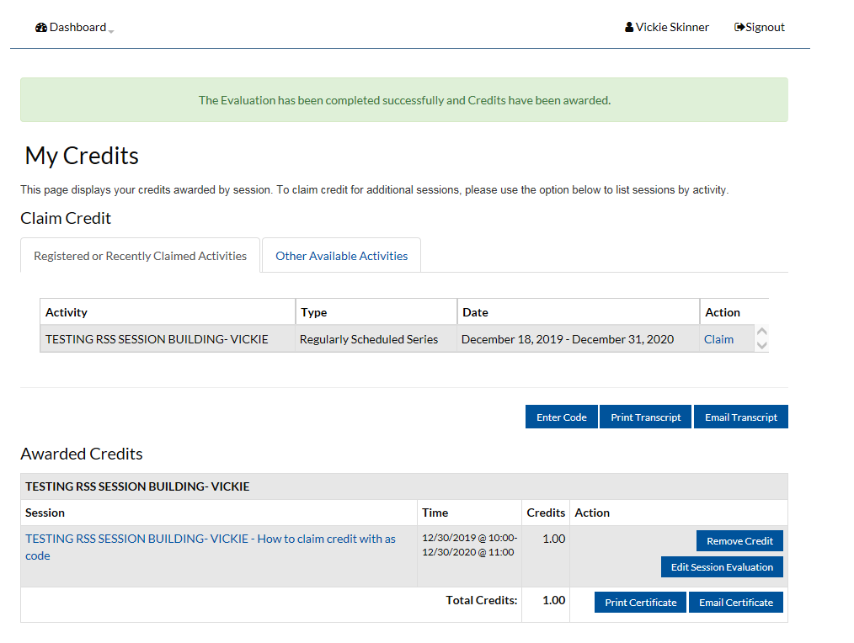

- From your ‘My Credits’ tab you can also enter additional authorization codes if you attended multiple sessions, or find other regularly scheduled series to attend.
PLEASE NOTE: You have up to 30 days from the date of the event to claim credit with an authorization code.

For any further assistance regarding the session, please contact the Activity Coordinator, or the person who provided the Authorization Code.

